Create Alert e FilterResources Use Cases

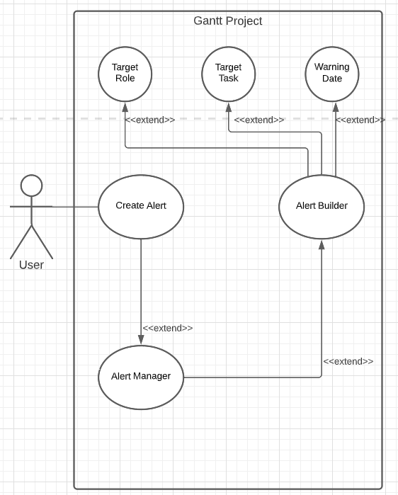

CreateAlertDiagram

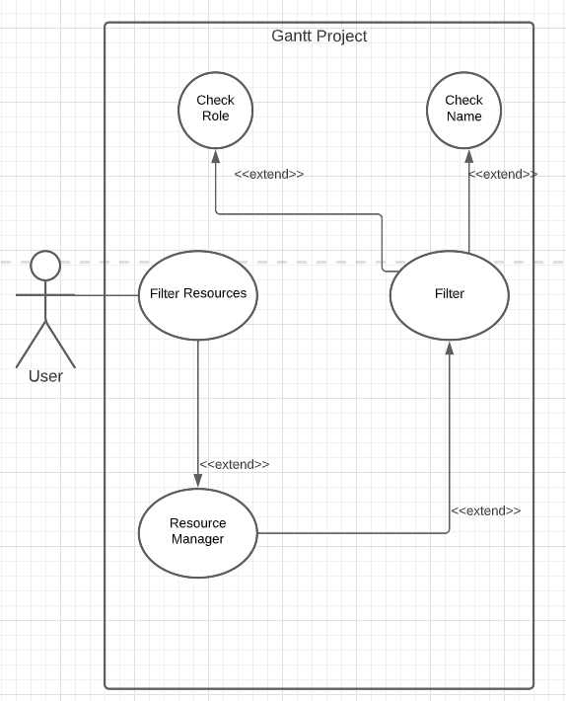

FilterResourcesDiagram